South West Roads Project:
Western Europe – Western China International Transit Corridor
(CAREC-1b and 6b)

Project Performance Annual Review Report
Period covered: June 2009 – December 2010

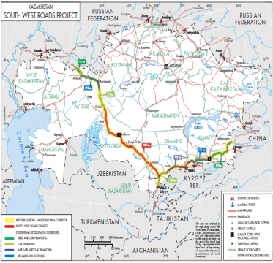 | 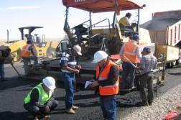
 | 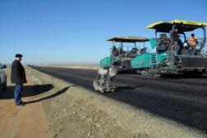

January 2011
The Ministry of Transport and Communications of the Republic of Kazakhstan
the World Bank
This document has a restricted distribution and may be used by recipients only in the performance of their official duties. Its contents may not otherwise be disclosed without World Bank authorization.

CURRENCY EQUIVALENTS
(Exchange Rate Effective: January 10, 2011)
Currency Unit | = | Kazakhstan Tenge (KZT)
KZT 148.00 | = | US$1.00
US$0.0068 | = | KZT 1.00
FISCAL YEAR
January 1 | – | December 31
ABBREVIATIONS AND ACRONYMS

ADB | Asian Development Bank
CAREC | Central Asia Regional Economic Cooperation
CR | Committee for Roads, MoTC
EBRD | European Bank for Reconstruction and Development
EIA | Environmental Impact Assessment
EMP | Environment Management Plan
ERR | Economic Rate of Return
GAC | Governance and Anti-Corruption
GoK | Government of Kazakhstan
HDM4 | Highway Development and Management Model (fourth version)
IBRD | International Bank for Reconstruction and Development (the World Bank)
ICB | International Competitive Bidding
IDB | Islamic Development Bank
IDF | Institutional Development Fund
IFIs | International Financial Institutions
IFR | Interim Financial Report
IFRS | International Financial Reporting Standards
MoF | Ministry of Finance
MoTC | Ministry of Transport and Communications
MOU | Memorandum of Understanding
NCB | National Competitive Bidding
NPV | Net Present Value
OP | Operation Policy (of the World Bank)
PMC | Project Management Consultants
POM | Project Operations Manual
RAP | Resettlement Action Plan
RPF | Resettlement Policy Framework
SNIP | Technical Standards and Regulations of the Former Soviet Union
TOR | Terms of Reference
TSDS | Transport Sector Development Strategy
WE-WC | Western Europe – Western China

Table of Contents

Table of Contents 5
1.Key facts on project 6
2.Updated country context and transport sector issues 7
3.Key challenges faced during 1st year of project implementation and how they have been addressed 7
4.Rating achievements during the 1st year of project implementation 8
5.Implementation issues hindering project performance during the 1st year 10
6.Challenges and strategy ahead for 2011 11
7.Annexes 14

Key facts on project

1 This report was prepared jointly by the Ministry of Transport and Communications of Republic of Kazakhstan (the MoTC) and the World Bank (the Bank) in accordance with the Section II, A of the Schedule 2 to the Loan agreement 7681KZ of June 13 2009: “[…] Not later than December 31, 2010, and annually thereafter, the Borrower, through the MoTC, shall carry out jointly with the Bank, annual reviews of the progress made in carrying out the Project (hereinafter referred to as the Annual Reviews). The Annual Reviews shall cover, amongst other things: (a) progress made in meeting the Project’s objectives; and (b) overall Project performance against Project performance indicators.”

Key Dates
Approved : April 30, 2009
Effective: December 9, 2009
Expected closing date: December 31, 2013
Financing Sources
Financier | Ccy | Amount |  | USD Equivalent
IBRD | USD |  | 2,125,000,000.00 | 2,125,000,000.00
GoK-Borrower | USD |  | 375,000,000.00 | 375,000,000.00
Total |  |  |  | 2,500,000,000.00

- Project Development Objective
- The Project Development Objective is to increase transport and trade efficiency along 1,062 km road sections between Aktobe/Kyzylorda oblast border and Shymkent and to improve road management and traffic safety in Kazakhstan, through the following components:
- Project Components:
Component 1: Upgrade and reconstruction of road sections (788.5 km - most of which will be 2-lanes) within Kyzylorda oblast (excluding the bypass to Kyzylorda).
Component 2: Upgrade and reconstruction of road sections within South Kazakhstan oblast (273.4 km of road sections, all of which will be dual carriageways with 4-lanes) from Kyzylorda oblast border to Shymkent, including the bypasses to Kyzylorda and Shymkent.
Component 3: Project Management Consultants (PMC) to assist the Committee for Roads with the management of all activities associated with the IFI projects.
Component 4: Institutional Development and preparation of action plans to improve road safety and road services.
- Component 5: Supervision of civil works under Components 1 and 2 and review of detailed engineering designs.
Disbursement as of February 7 2011
Financier | Financing |  | Disbursed | Undisbursed
IBRD Loan |  | 2,125bln | 338mln | 1,787mln

Updated country context and transport sector issues

2 Following two and half years of financial crisis, the recovery of the Kazakhstan economy in the first half of 2010 has exceeded expectations. GDP growth for the first half of the year is expected at over 8 percent relative to the same period in 2009. Most sectors and regions have experienced significant growth, with the notable exceptions of construction and financial intermediation. Fixed capital investment financed by domestic sources was 20 percent higher than during the same period of the previous year. Real incomes continue to grow, unemployment has declined, and the official poverty headcount has reached a record low.

- 3 In spite of the crisis the GoK increased the financing to the roads sector (KZT219 billion in 2010, 8 times more than in 2001) and embarked on an ambitious roads development program– the Western-Europe-Western China International Transit Corridor Project (part of CAREC)-to stimulate economic growth and reduce poverty in the poorest parts of the country, by improving access to regions, as well as providing employment in the construction sector and related services. Overall about 65 percent of the total amount of the Western Europe to Western China (WE-WC) Program is co-financed by the IBRD, ADB, EBRD, JICA and IsDB, covering improvements to the 2,840 km road corridor linking China through Kazakhstan to Russia. IBRD, through the South West Roads Project (the SWRP) finances a 1062km section of the WE-WC from Shymkent in the South to the Northern border between Kyzylorda and Aktobe oblasts.
4 The overall objectives for the transport sector in Kazakhstan are identified in the Government’s Transport Sector Development Strategy 2006-2015. It defines investment programs that include rehabilitation of the Republican (National) road network (Figure 1), the provision of selected additional infrastructure, particularly along CAREC corridors, and institutional and legislative changes.
Figure 1. Kazakhstan Republican Road Network
by Condition (km, %)
5 The geography, population, economy and trade flows of Central Asia have an important bearing on transportation challenges in Kazakhstan. Within the region, distances are substantial (2,000 km from the
- Kyrgyz Republic to Russia) and access to major markets involves very long travel distances. For the region, trade with Russia continues to be important mainly due to historical reasons with much of this trade transiting through Kazakhstan due to the availability of transport infrastructure. China is growing in importance as a trading partner for the region, with Kazakhstan taking the largest share.

Key challenges faced during 1st year of project implementation and how they have been addressed

6 The SWRP, supported through a USD2,125 million loan, remains the biggest project in the Bank’s as well as GoK’s history. The project was ratified by the Kazakh Parliament in 12 days --a record time-- setting the pace for the parties involved to complete the project by an ambitious deadline set to January 2014.

7 The first year of implementation of the project faced numerous challenges. Those were mainly related to the pressure to implement the civil works rapidly and to the early deployment of contractors. Challenges were also due to the large size of the project and the lack of previous experience related to certain activities (such as the procurement of large batches of civil works).

8 The Bank team and the Committee for Roads at MoTC (the CR) rapidly agreed on an implementation schedule. A project launch took place in Astana in July 2009 to agree on an action plan and an implementation schedule for the procurement of civil works. The agreed schedule was also focusing on allowing the CR to spend State Budget funds earmarked for component 1 before the end of 2009 calendar year, and subsequently for component 2 before the end of 2010 calendar year. During the first six months the CR was able to launch the project, prepare and complete procurement for 14 lots (covering all civil works in Kyzylorda Oblast –Component 1 of the project) worth US$1.2 billion. Supervision and other consultancy services were procured as well. The disbursement condition attached to activities under Component 2 (civil works in South Kazakhstan oblast --SKO) was met at the end of December 2010, allowing the first payments under component 2 to occur as planned by the end of the calendar year 2010. Meeting this condition was not only related to procurement and social (RAP), but also to an institutional challenge as the disbursement condition required a political commitment from high level decision-makers to embark on an institutional reform to strengthen the CR –a target that has been achieved.

9 From the early start of the project, the Bank Project Team and the CR ran weekly audio meetings to address in a timely manner any issue, and keep a satisfactory level of responsiveness and pro-activity. This pattern was also very useful because at the beginning and for about six months, the CR did not benefit from the assistance of the Project Monitoring Consultants (PMC) as the PMC became operational only in December 2009. Weekly audios helped tracking progress at the Bank and at the CR, and have greatly facilitated the decision process. Short minutes of the audios were drafted by the Bank Project Team and shared with the CR. One other important purpose of the audios was to build confidence between the two teams and to allow for on demand brain-storm sessions. These objectives have been met.

10 Procurement of civil works was completed on schedule, but it has been a major challenge due to the number of lots and the size of each of them (14 lots under Component 1 estimated USD 1,422 million, and subsequent 7 lots under Component 2 estimated USD 896 million). The CR was required to produce a series of prequalification reports and bid evaluation reports, each of them being reviewed by the Bank Procurement Review Committee because of the size of the civil works. Both teams tried to speed up the process as much as possible, but the process still remained time-consuming by construction and there has been many back and forth before final agreements on the various reports. Effort focused first on the 14 lots under Component 1. The Bank and the CR considered the process very challenging with 26 applicants bidding all bidding on 14 lots. The evaluation was even more difficult because of conditional/cross discounts and financial and technical capacity provided by each applicant. The Bank Team had anticipated such complexity. The team took the initiative to develop a user-friendly Excel-based matrix to compute the lowest total cost solution for the 14 lots taking into account all financial and technical requirements. The matrix was handed over to the Committee for Roads for the purpose of conducting the evaluations. The use of this matrix saved time and secured the process. It also allowed to ascertain that the civil works were awarded based on the right combination of lowest evaluated bidders. The same process was repeated later during the evaluation of 38 other bids for 7 lots in SKO (Component 2).

11 The contractors mobilized rather rapidly --although for some of them not fully-- and works started at the beginning of the 2010 construction season, on schedule. Most of the construction activities started about two months before Consultant’s Supervision staff deployed. As for the works themselves, the Bank Project Team did notice early in the process that the planned infrastructure was overdesigned at some locations. The Supervision Consultants and the PMC were asked to run again a review of the detailed design and make recommendations for the CR (e.g., Terminalovka bypass and related discussion with the designers of the status of the detailed design for the alternative option for the bypass).

Financial Management also required a lot of attention and it took time to set it up in a proper way. The fixing the CR accounting software took more time than initially expected. It was necessary that the software works to facilitate automatic generation of financial reports. It has also been necessary to work on improving reporting, revising the financial section of the Project Operational manual, signing of a service contract for maintenance of the budget software etc. At the beginning the CR was not allowed to open a Designated Account. Consequently all payments in 2009-2010 were made through a large number of applications submitted to the Bank Regional Processing Center office in Zagreb sometimes on exceptional basis because the applications were below the required agreed minimum amounts. But in November 2010 the MoF agreed to open the Designated Account for the project in the Treasury of the MoF with USD10 million maximum allowed amount. The new process is expected to become operational ahead of the 2011 construction season.

Rating achievements during the 1st year of project implementation

Project launch
12 The project was officially launched by the President of the Republic of Kazakhstan in Aktobe in September 2009. Another technical meeting took place in July, 2009 in Astana. The July technical launch allowed all the parties involved in the implementation of the project to share common understanding of the main challenges, constraints, and requirements. The participants agreed that the main focus should first be (i) procurement, (ii) the completion of environment and social work associated with the Bank safeguards requirements and (iii) the preparation and implementation of a communication strategy.

Institutional reform
13 By fall 2010, the MoTC and the World Bank started discussing the need for strengthening the CR (hereinafter – the Committee) and improving the overall condition of the road network. The objective was to (i) improve the management of the road network, (ii) increase the quality of the works and, (iii) ensure the independence of monitoring the efficiency of use of the allocated funds and the quality of executed works. By December 2010 an agreement was reached on a Framework of Actions proposed by the MoTC. The Framework of Actions and its underlying detailed Action Plan are designed to achieve the following objectives in the short- and medium-term:
(i) Short-term period (first year of the Action Plan):
- Designing an incentive system for staff of the Committee and its oblast departments;
- Increasing the quality of composition of staff capacity through selection of qualified staff and providing training;
- Decentralization of the Committee by transferring parts of its functions to the oblast departments;
- Strengthening the role of the Design Institute “Oblzhollaboratory” to improve the quality control of executed works and used materials;
- Enhancement of the terms and conditions of the contracts for civil works, design and supervision to increase the quality of the final product;
- Undertaking detailed review of activities carried out by the State-owned Enterprise “Kazakhavtodor” with a view to partially transfer routine repair of roads and landscaping to the private sector.
(ii) Medium-term (second and third year of the Action Plan):
- Analysis and review of the international experience in managing the road sector by autonomous road agencies and further submission of reform proposals to the Republic of Kazakhstan.
- Study of the international experience on ensuring stable sources of financing for the road network development and further submission of reform proposals to the Republic of Kazakhstan.
14 The implementation of the Action Plan will start in early 2011. Progress will be reviewed jointly by the World Bank and the MoTC by the end of each calendar year until the completion of the SWRP.

Procurement
15 All civil works under component 1 (14 lots for the upgrade and reconstruction of road sections in Kyzylorda oblast) have been awarded in December 2009. The four civil works supervision teams have also been designated and have deployed. Works started in March 2010. As already mentioned above, the procurement of the civil works has been demanding. It required five meetings of the Operational Procurement Review Committee (OPRC, the highest procurement committee at the World Bank) for the Bank to provide no objection on the award of the contracts. The Bank Project Team has engineered and provided the Borrower with an Excel-based matrix that calculates automatically the lowest cost combinations of packages taking into account the financial and technical capacity of each applicant and comparing it to the criteria issued from prequalification stage. OPRC has asked the Bank Project Team to have method and results checked through an alternative and commercial software that calculates optimization of the attribution of the 14 lots. The Team has contracted a programming specialist to compute the data and verify the tool created by the Team and the results obtained by the Borrower. The CR has then run the model and assessed that the Excel based tool was functioning properly and provided the right combination of lowest evaluated bids.
16 While the estimated cost for the 14 lots altogether was about US$1,422 million equivalent the contracts awarded in line with the Bank’s procurement principles with unique and lowest total price amounted to US$1,026 million. Variation compared to total estimated cost makes up 28% with an exchange rate at the time of the bid opening of 1 US$ = 150.88 KZT. Having considered to be the most acceptable due to greater saving for the budget and greater number of contractors to execute construction works the contract packages are distributed as following: Lot 1-5 “Salini Construttori S.P.A.”, Italy; Lot 6 and 8 JV “Akkord” and “OKAN”, Azerbaidjan/Turkey; Lot 7 «Impresa S.p.A», Italy; Lot 9-14 Todini Costruzioni Generali S.p.A., Italy.
17 All civil works under component 2 (7 lots for the upgrade and reconstruction of road sections in SKO) have been awarded in December 2010. The Bank Project Team has been presenting the procurement case to OPRC at 4 different meetings, relying partly on experience gained during the procurement of the 14 lots. The works, together with the supervision contracts, have been eventually awarded in December 2010 after the following conditions have been met: (i) the processing of phases one and two of the assignment under Component 4, Institutional Development, namely an agreement between the MoTC and the Bank on a framework of actions to strengthen the CR; (ii) the completion of the Resettlement Action Plans (RAPs) for the new alignments in SKO before civil works start; and (iii) the procurement of the civil works, which had been completed in November 2010. Works are expected to start in March 2011.
18 Upgrade and reconstruction of road sections within SKO (including the bypass to Kyzylorda) was estimated US$896 million equivalent. The total awarded contract prices for 7 lots in SKO amounted to US$491 million with 46% savings due to competition and with an exchange rate at the time of the bid opening US$1=KZT 147.28. The successful contractors include: Lot-1 "Azerkorpu", Azerbaijan; Lot-2 “Dena Rahsaz Construction Co.”, Iran; Lot-3 JV "Copri Construction Enterprises » & "Seiser Ltd", Kuwait/Kazakhstan ; Lot-4 “Posco Engineering Construction CO. Ltd”, Korea; Lot-5 “Sinohydro Corporation & Limited”, China; Lot-6 “Kukdong engineering & construction Co., Ltd”, Korea;Lot-7 JV “Azerkorpu” & “Tepe Insaat”, Azerbaijan/Turkey.
19 In addition, tendering of consulting services for the supervision of both Component 1 and 2 of Civil Works has been completed on time and contracts have been awarded before the start of the Civil Works.

Civil Works Status and Supervision
20 Both the Bank Project Team and the CR put great emphasis on the quality of the civil works. In order to embark with all stakeholders on a path towards performance, a workshop on Construction Quality has been organized by the CR on February 22, 2010. According to all participants, the workshop has been a success. The main theme was “Managing the SWRP Civil Works, setting the bar for Quality, Costs and Time”. All participants involved in the civil works financed under the project participated including the contractors, supervision consultants, PMC, ADB and IsDB. The objective was threefold: (i) a discussions about the notion of continuous improvement of quality, (ii) a description of the actors and their responsibilities, and (iii) the trade-offs between quality, cost and time. The workshop provided a timely opportunity for all participants involved in the construction of the new road, including the IFIs, the supervision teams, the contractors and others, to meet and discuss the basics of enhanced quality management during the implementation of the project.
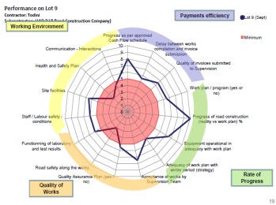
21 In order to ensure that these principles were taken into account at the implementation stage, the Bank Project team developed a methodology to be applied to the review for each lot and the performance of both contractors and supervision consultants. The objective was to broaden the assessment beyond the monitoring of physical outputs and to identify the activities that needed improvement in order to foster the construction. The aim was also to implement one of the principles under the Governance and Anticorruption Action Plan, namely an enhance supervision by the Bank. The Bank Project Team suggested criteria both for contractors and supervision.
22 Figure 2. Example of Radar Chart for Contractor
Nine criteria were used for contractors, namely: (i) topography, (ii) mobilization, (iii) deployment of equipment, (iv) laboratory, (v) cash flow forecast, (vi) submission of payments, (vii) preparation of EMPs, (viii) monitoring of environment on site, and (viii) traffic management and road safety during construction. Five different criteria were used for supervision teams, namely: (i) acceptance of the work program, (ii) grievance mechanism, (iii) review of the detailed design, (iv) reporting, and (v) interaction with the contractors. (see annex for detail of the contractor’s performance)

23 The method also provided a fair and level playing field to each stakeholder, with minimum level targets and progressive scoring. Radar charts were used to report the results in a visual way and highlight the activities that were not meeting the minimum requirements. Lines were drawn to connect the data values for each axis, giving the results a star-like appearance – the larger the star, the better the results. After about 9 month, works were catching the required momentum. It is expected that all the Contractors will be back on schedule by the beginning of the 2011 construction season.

Governance and Anti-Corruption (GAC)
24 The GAC for the SWRP was designed around the following concepts: (i) the PMC involvement; (ii) a focus on institutional reforms and capacity development; (iii) the introduction of internal controls and audits; (iv) the implementation of Bank procurement procedures, (v) an emphasis on the oversight of the civil society; (vi) the set up of a complaint handling mechanism; (vii) independent technical and procurement audit; and (viii) enhanced Bank supervision. All those principles and actions are in place, with the exception of the independent technical and procurement audit, which is being procured and financed out of an IDF grant. Some specific highlights are worth noticing:
(i) No corruption or illegal activity has been reported under the project so far. For each contract financed by the World Bank, Clause 15.6 “Bribery or fraud” of General Conditions of the Contract, describes the contractors’ responsibility toward fraud and corruption.
(ii) NGOs and the civil society have been heavily involved: While emphasizing in-principle positive attitude towards the road project and willingness to cooperate with all stakeholders, a local NGO (the so-called Public Monitoring Group of SKO) brought forth a number of issues, which eventually led to a complaint to the World Bank Inspection Panel recorded in April 2010, and further visit of IP team to Kazakhstan in May-June 2010. The complaint was brought up by some of the residents of Birlik settlement in the town of Turkestan (SKO). The complaint mentioned that the construction of a 4-lane road near the settlement could be damaging to the community as it would generate (i) potential harm to the health of the residents of the settlement from fumes, pollution and noise; (ii) harm to the environment, in particular from accidents and spills from trucks transporting flammable and explosive materials; (iii) risks to the safety of school children crossing the road daily as a result of higher traffic volume and speed; (iv) possible impact on houses and related involuntary resettlement, and (v) the transit traffic flow in the heart of the city of Turkestan will increase significantly in the future and “will become an environmental disaster for its residents. Turkestan is viewed as the second Mecca for Muslims around the world. The city’s potential unsafe life and health conditions for Muslim pilgrims will result in the irreversible damage to the budget of the city, as well as to the income of urban residents benefiting from tourism.”
The CR was aware of those facts and actually they did order an amendment of the design (mainly shifting the alignment away from the settlement). The revision of the design was completed in December 2009 and consulted upon in February 2010 in Turkestan and in Birlik settlement. The CR and local officials committed to a series of mitigations measure: The CR actively engaged the local communities particularly in the Birlik settlement to respond to concerns raised and resolved issues to the satisfaction of the majority of the local population around Turkestan city, including residents of Birlik settlement. Following an initial review of the situation on the ground, and based on the Bank management response, the Inspection Panel concluded that the complaint sent to them was not eligible.
(iii) Bank supervision over civil works has drastically improved by using a Performance Assessment Tool. The Performance Assessment Tool (PAT) was developed by the Bank Project Team (see description under section C “civil works status and supervision” above and full result for the 14 lots in Kyzylorda oblast in annex). The strategy lead to common understanding of the performance and challenges related to the civil works, shared between the Bank, the CR, the PMC, the supervision teams and the other IFIs also financing investment along the corridor. The Bank Project Team is now in the process of gradually transferring the management of the PAT to the PMC and the CR. The outcome --a clear, very visual, and impartial review of the performance of the contractors-- has been very well received by the MoTC, as well as by management at the Bank and it is now a standard for supervision of civil works under the SWRP.

Communication strategy at the MoTC
25 Regarding the progress of civil works: MoTC manages information about progress, from the contractors, in the form of summaries, tables, slides and recurrent reports about the executed work. In addition, following each visit to the construction sites, the staff of CR and PMC also bring information and progress reports, including progress of works, positive experience as well as issues to be resolved. Wrap-up meetings are organized at MoTC RK and CR, with the participation of PMC, supervision consultants, main contractors and subcontractors. There are also weekly and monthly meetings chaired by the CR, with the participation of supervision consultants and contractors, to share information, review the construction schedule, consider in details all the matters, connected with work, living conditions, matter of traffic safety, observance of the rules of labor protection and safety methods and share their opinions in all the problems, which occur.

26 Project webpage by the CR / PMC: Aiming at the information support of the Project “International Transit Corridor “Western Europe – Western China”, website” New way to Europe” (www.europe-china.kz) has been developed by the CR and the PMC and operates since July 1, 2010. The website was officially introduced on July 1, 2010. It provides news from the construction sites, contact points, information about the procurement and about the MoTC, large volume of photo and video material, interviews and television channel news as well as information about Resettlement Policy enforced under the project, Environment Management Plans, etc. The website also offers a “questions and answers” section with 46 entries as of January 2011. Editorial staff of the website visited all construction sites in November 2010, preparing and distributing press-releases on construction world progress. A large volume of photography and video were made and posted on the website Together with audio records of interview and conversations with representatives of contractors and subcontractors, supervision team and various workers. The site visit also provided an opportunity to record everyday life, i.e., living conditions, catering provision for people, working at the sites etc. These matters are also posted on the website.
27 Public consultations: Public hearings were conducted with participation of NGO (e.g., B. Issaliyev, leader of the Social Monitoring Group for SKO), representatives of local authorities, community, and the actors involved in the preparation and implementation of the project. The two main consultations focused on (i) the design “Temirlan by-pass” (Ordabassy district), executed by “Donsung” company, and (ii) the design of the “Staryi Ikan village by-pass” (Turkestan district).

Dialogue with NGO and Civil Society
28 The Bank Team initiated and continues to maintain a dialogue with the Coalition of NGO. The aim was to discuss the various questions raised by the NGO since June 2009 in a series of letters sent to the CR, the Bank Project Team, the Inspection Panel, World Bank’s Integrity Vice Presidency (INT) and the Bank Information Center (BIC). The main objective was to build a constructive and proactive working environment, while providing the NGOs with detailed answers on their specific questions. Indeed, the project clearly identifies from the start “Civil Society Organizations” as entities that should actively participate in the project.
29 The Bank Team and the CR discussed the creation of a Tripartite Commission (PMC, CR, and NGO). This came as an answer to a request of the Public Monitoring Group of SKO associated with the NGO “NAIR” (represented by Mr. B. Issaliyev). The PMC through the social development specialist based in Shymkent (SKO) and PMC public relation specialist in Astana also provides support to reach out civil society at large for information exchange, dialogue and participation. “NAIR” NGO sent to the CR and the Bank two requests for financing their activities. The Bank Project Team and the CR have discussed potential involvement of NGOs such NAIR in the monitoring of environment and social matters during the civil works and also on the possibility for NGOs to help identifying the need for services under Component 4 of the project. The financing of such activities by NGOs is a possibility detailed in the World Bank procurement guidelines. The CR did not come to a decision on this matter yet.

Employment and local economic impacts
30 The project is providing local employment to the region. Supervision Consultants, the main Contractors and Sub-Contractors are hiring local staff for the implementation of the project. So far the project has provided the employment to about 35,000 persons. Local staff is hired though local employment exchanges, local authorities, advertisement in local papers and other means. Training has been provided by Contractors and Sub Contactors though various agencies employed by them. Local authorities such as the Akim’s office in Kyzylorda Oblast have also taken the initiative to organize training for workers to be able to participate in the reconstruction of the road. As per September 2010 observations, it is worth noting that about 45% of the total contractors’ and subcontractors’ workforce is represented by local workers from Kyzylorda region, and that about 75% of the same total workforce is from Kazakhstan.

31 The project is also having a very positive impact on the construction industry in Kyzlorda and South Kazakhstan Oblasts. For the first time in history more than 2 billion dollars are being injected in the local economy. Many local and national sub-contractors (general as well as specialized) have been deployed to participate in the project, increasing their annual turnover and allowing them to build up their credentials for future bidding. All material required to be incorporated for construction is being purchased locally (e.g., cement, aggregates, precast units etc). Even at the national level various other materials like bitumen, geotextiles, armature, guardrails etc. are supplied from Kazakh factories. Most of the equipment which was lying idle for long time is now used and lots of new equipment have been brought. Finally, about 35,000 workers are deployed directly at present and this number will grow when the civil works in SKO will start in March 2011. Lot of new staff is being trained to operate new heavy equipment. There is no doubt that this technology transfer will become a big asset for future investment in the road sector.

grievance mechanism, hiv/aids, and workers rights
32 Grievance Redress Mechanism. The contractors and the supervision teams in charge of the ongoing civil works have been asked to put in place a grievance mechanism so that affected people and the public at large can interact with the project when needs be. Before such mechanism, the PMC was gathering complains when they arrived and there was little interaction between the actors involved in the civil works and the populations. A log now exists, and remedial actions are designed and discussed between the PMC and the complainants. Most of complains has been first directed to the contractors and the supervision through the local Akimats (the local authority). Although this system seemed to function and serve the purpose, the Bank Project Team did ask to ensure that all complains could be registered and addressed. The PMC has prepared with the CR a detailed manual on grievance mechanism. Most supervision teams have nominated a grievance coordinator, but without clear TOR. More guidance will be needed in 2011 to help bridging this gap.

33 HIV/AIDS Awareness Program. Civil works contracts under the project have a provision that states that the contractor shall throughout the contract (i) conduct information, education and communication campaigns, at least every other month, targeting their staff and the immediate local communities, about appropriate behavior with respect to Sexually Transmitted Diseases in general and HIV/AIDS in particular; (ii) provide male or female condoms for all site staff and labor as appropriate; and (iii) provide for STD and HIV/AIDS screening, diagnosis, counseling and referral to a dedicated national STD and HIV/AIDS program. All four civil work main contractors have appointed ‘Medical In-charge’ for the health safety of their staff and HIV/AIDS program. Nonetheless, HIV/AIDS program is not implemented according to the conditions of the civil works contracts. Only a few staff is aware of the program. Considering the large number of staff, it is necessary to design HIV/AIDS awareness program better. Not sufficient attention is given to prevent and control the HIV/AIDS; only manuals and a limited number of condoms have been distributed. The focus is given only on health checks up and HIV test/checks up of the key staff but other stakeholders are not considered like immediate community, drivers and other crew, and commercial sex workers who are numerous in the region. While the latter are well aware of HIV/AIDS, interviews have highlighted that condoms are not always used. A HIV/AID information campaign targeting truckers (based on the toolkit issued by the International Labour Organization) will be implemented through local NGO in 2011.
34 Social security and labour rights. All contractors are taking measures toward workers social security, safety and health. Once every two months the contractors are organizing special training on safety and social security. There are provisions of special allowance (family members) if the worker is sick or dies at work (no such occurrence reported). All the required measures are taken to protect workers’ health during work time like provision of special cloths, helmets, gloss, safety shoos etc. transportation (from camp to work site) and accommodation facilities are also provided to all the staff and workers. All the camps, especially sub-contractors have kitchen facility for their staff.

Project performance against Project performance indicators
As mentioned above, the objectives that were set to the project during the project launch workshop for the year 2010 have been achieved. Most of the project performance indicators relate to mid-term or end of the project implementation period. It is therefore too early to compare the performance to the indicators by the end of year one, with the exception of the following that can already be reported:
- Number of kilometers of roads upgraded (cumulative km): Objective 2010: 0km; Actual: 130km.
- Works, Goods, and Consulting Services contracts processed and managed by the PMC: Objective 2010: 3 (W), 2 (G); 2 (CS); Actual 21 (W), 0 (G); 7 (CS).
- Training received by the Committee staff from PMC (staff-hours): Objective 500; Actual (PMC ESTIMATE)

Implementation issues hindering project performance during the 1st year

Resettlement
A Resettlement Policy Framework was published in May 2008 and was a uniform document covering all sections financed by the WB, ADB and EBRD. The completion of a Socio-Economic Census of Affected Households within the first six months of effectiveness was a condition of the waiver granted by the World Bank Board in March 2009. The Bank team has provided assistance to the CR with a sample socio-economic survey instrument that has been used to collect the data on households affected by the acquisition of land, demolition of structures and other assets. The survey collected data on income levels, income sources, the assets to be removed and household dependence on those assets. This survey was used for the preparation of the Resettlement Action Plans (RAP). The RAP for Kyzylorda oblast (Component 1) was approved in 2009, disclosed and locally discussed in public hearings held in the relevant Rayon Centers. The RAP for the South-Kazakhstan oblast (Component 2) was still under finalization at the time of the preparation of this report but was later approved in March 2011. Preparation of RAP for SKO has been more difficult since SKO is the highest populated oblast of Kazakhstan and it took more efforts from the CR and PMC to complete it. The NGO NAIR is also engaged in the process of RAP preparation and finalization through provision of comments and revisions to the draft RAP and monitoring of compensation process in the field. The CR finalized the SKO RAP in March 2011 to have the Bank’s approval prior to physical commencement of civil works in the SKO in Spring of 2011.

Civil Works
The Contractors and the Supervision Consultants have, at very early stage, highlighted their commitment towards good quality and the delivery of a higher level of service to the users through the upgrade of the road. The Quality was seen through the prism of the physical outputs (the sustainability of the capital investment) but also through the process itself (e.g., the focus on users, leadership, involvement of staff etc.). It implies, for the civil works contractors: proper management of traffic during construction; technical excellence; capacity to anticipate; and avoid decisions that would generate conflicts or coercive measures, and for the supervision consultants: presence on site, leadership; implementing FIDIC terms with fair-mindedness; active role in keeping control on quality, costs, time; and sharp and efficient reporting. Despite the above engagements, Project Team observed different behaviors and patterns on site. Outputs are detailed hereafter.
The Main issues relate to several of the 14 lots (i.e., component 1, Kyzylorda Oblast), mainly lots 1, 2, 3, 7 and 11. For lots 1 and 2, only one sub-contractor for the 2 lots has been identified, despite the fact that these lots are rather large (respectively 90km and 68km). This may jeopardize the overall progress of the works, as the sub-contractor does not seem to be able to handle all work, and would need additional equipment to be provided by the contractor. Only one-subcontractor for the 2 lots (10 and 11) has been identified, and works have been focusing on lot 10. The sub-contractor does not seem to be able to handle the volume of works on both lots in a timely manner. In addition to these main issues, there are also problems of water stagnating along the alignment of lots 8, 10, and 12. Lots 7 and 8 are considered problematic by the CR and therefore are been considered for termination of contracts. The CR estimates that both contracts are causing serious concerns due to overall slow mobilization, frustration of time programs, and absence of proper work organization (as of March 2011, the date of completion of the present report, those issues have been solved). The Bank did not considered these lots as problematic during its review conducted during the mission, and therefore thought that the original reasons that have caused initial delays have been solved and therefore the works can probably move forward in a satisfactory manner. In addition, the Project team has recognized that both contractors are currently putting all their efforts in the civil works so that they catch up with the delays.
Environmental performance has been assessed against compliance with safeguards, impacts of civil works and interactions with project affected people. The overall picture is average. Grievance mechanisms are not yet functioning properly. In a number of lots it was observed that environmental performance was below the benchmark minimum, i.e. the basic acceptability under international good practice. The Team also found a clear negative correlation between percentage of subcontracted works and environmental performance. The Team has highlighted the fact that poor environmental management, lack of EMP implementation, and lack of knowledgeable staff pose serious risks, both in causing physical harm and reputational damage for the project parties. On the other hand, environmental performance in a few contracts demonstrated that good practice and due diligence are achievable in the project context. In addition, there appeared to be a positive correlation between overall works performance and environmental due diligence. In conclusion, the Bank Team recommended that there should be permanent site presence of qualified staff with authority on the works, and hands on skills at all levels (contractors, supervision consultants, PMC). Environmental practice can only be improved if the subcontractors also acquire the required skills and staff for diligent EMP implementation. Contractors should reinforce transfer of knowledge to local workforce. These are approaches to explore in 2011.

Supervision
During project preparation, it was decided in agreement with the CR that, in case a Supervision firm that is short-listed for multiple lots wants to bid for more than one lot, the firm should be required to submit separate proposals with different teams of full time key staff. In spite of this requirement that constrained consulting firms to organize strong teams, most of the Supervision firms have had their key staff changed during the first year of implementation of the project. Such issue is not particular to this project, however World Bank based procurement and current contracting possibilities do not enable a different framework. The Project Team considers that contracting each key staff under the Supervision consultant contract could be a suggestion to consider within the World Bank procurement guidelines; such arrangement is widely used in public procurement in Europe.

In particular, Supervision team for lots 1, 2, 3, and 4 is problematic. It appears from the Project team assessment and review that there is little interaction between contractor and the supervision team. Monthly meeting, as per requirement of contract, are not conducted. There is no daily or weekly meeting between stakeholders. Detailed designed has not been reviewed as per contract. Monthly reporting is not implemented. Finally and most important, the supervision team have proceeded to replacement of key staff in April 2010 on the basis of misleading resumes, and therefore replacing staff do not par with original key staff in terms of language skills. Language barrier, who is an issue as regards of the interaction between supervision team and contractors, is now even more critical. There have been a lot of changes in the Supervision Key Staff for the Supervision Consultants. The table in Annex 4 shows the changes made in the year 2010.

Payment efficiency
The average processing time for Interim Payment Certificates (IPCs) is about 2 months (compared with 56 days mentioned in the contracts). It was found that there are too many procedural steps to get final payments and that the volume of documentation required to process IPCs was too large. The high volume of documentation and the clearances involving bodies such as the Regional Laboratory of the Committee for Roads are two key steps that still need to be simplified in order to gain efficiency and time. It was also advised that one project manager and one quantity surveyor from the supervision consultant shall be maintained on site along with the contractor to enable strict control and reconciliation of quantities on a weekly basis.

Disbursement
The Disbursement was low for the year 2010 due to the fact that the Contractors were slow in mobilizing to the site. Nonetheless it matched the objective set by the Government. As this being the first year for civil works, the contractors had to mobilize the Construction Equipment to site, establishing the site facilities, getting all the required permission related to the works and starting the works. There were initial difficulties in getting the work permits for the expatriate staff, procurement of materials etc. which slowed down the production for the first year. The targets for the year 2010 as 50.76 Billion Tenge which were given by the Supervision Consultants & Contractors were not achieved due to above listed difficulties. The details for disbursements for each month in the year 2010 are given in Annex at the end of this report.

Road services and Road Safety
Road Safety. Road safety is a real concern in Kazakhstan. With the growth in motorization, road crashes have become an increasing issue. Regular work has been conducted from the Employer’s part on improvement of the legislative base of road safety. Measures have been taken on rigging the Republican State Enterprise “Kazakhavtodor”, engaged in exploitation of highways of republican and international meaning, with material-technical resources for their bringing to the standards. Together with it, allocation of resources for financing works on exploitation of highways of the common use has been made under the leftover principle and does not comply with the approved standards.
Road safety on construction site is not sufficient. Although traffic management plans have been developed, consulted with and agreed upon by the police and local authorities, actual management is not adequate yet. Signage is not sufficient, and works are not properly and visually signaled and separated from the traffic. Technical specifications including signs, barriers, lighting, “stop-go” signboards and signing are not implemented. The signage is often not large enough and not visible from the road – even during day time. Traffic management plans are said to be compliant with Police standards, however speed limits do not match sound traffic management. There have been reports of 8 accidents/incidents along the work sites since construction started, with no casualty. Communication campaigns on the schedule and organization of the works along the road with a focus on road safety are missing (e.g., “zero accident campaign”, information about ongoing works, location of main entrance to construction sites, hours of operation, management during night, etc.) A well-structured accident prevention campaign, which could substantially help modifying speeding behaviors, should be considered in 2011.
Road Services. The lack of services geared towards the different types of road users (e.g. local population, national and international transporters) is not addressed formally yet although a significant volume of new activities linked with the arrival of a large number of workers can be observed. The government could play an important role in fostering investments by the private sector to provide road services. The SWRP is design to help implementing such strategy (by consulting with various stakeholder during the preparation of an action plan). Those activities will be implemented in 2011 i.e., the second year of implementation. The main beneficiaries are expected to be road users in general as well as local communities along the Corridor.

Communication
The PMC launched online forum, which should have allowed MoTC, COR, PMC, Contractors, Supervision Consultants and IFI to share their ideas, best experience and results for the project. This idea was not implemented due to the lack of participation of the registered members.

The setup and maintenance of the project web site by the PMC has been much more successful.

On the date of March 14, 2011, in general 20 907 visitors have been visited (6 583 for November 1, 2010) the site, and 118 319 pages have been looked through (41 968 for November 1, 2010).

The number of countries-visitors increased from 51 (for November 1, 2010) to 86 till date. The total number of the visitors accounts for 10 616 persons, whereas it was 6 584 only for November 1, 2010.
Number of countries-visitors, including: Kazakhstan - 15 430 (5 327), Russia – 2 403 (457), Germany -334 (104), USA – 259 (74), Ukraine – 258 (79), Great Britain – 252, Tajikistan – 154, Uzbekistan – 121, Turkey -102, Italy - 94, Azerbaijan – 92, India- 92, China - 92, Bulgaria - 90, Belorussia - 89, Southern Korea - 85, Netherlands - 72, France - 40, Japan -35, Canada -26, Israel - 6 etc.
The results of the analysis says about the increasing interest to the Project of such countries as Russia, Tajikistan, Germany, USA, Canada, China, Italy, Great Britain and others.
Among new visitors the following countries appeared on the map of visits – Finland, Ireland, Australia, Columbia, Saudi Arabia, Singapore, Argentina, Kenya, Hong Kong, Egypt, Romania, Guinea, Katar, Tunis and others.
The following key words have been used more often while looking for information, required for the visitors: Western Europe – Western China, Great Silk Way, Silk Way, www.europe-china.kz, as well as the names of Contractors, CSC, design institutions, etc.
By this moment the number of pages with printed output is 389, 258 of which have been published. Including: Press-releases (News) – 114, digests (Mass Media review about the Project) – 128, as well as articles and interviews -16. Photo materials – 922 and video materials – 39 have been published in section “Multimedia”.
55 questions have been received on site for the period since June 18, 2010, to March 14, 2011, on which the answers have been published within 1-3 days.
Since February of the current year the site works in two languages: Russian and English. An agreement has been signed between the branch of the company SNC Lavalin International and IE “Cherednichenko I.A.” for content support (maintenance) of the website on March 10, 2011. Tables with statistical analysis have been enclosed to this report.

Challenges and strategy ahead for 2011

Getting Baseline
The year 2010 has been the first year of implementation of the SWRP and as already mentioned at several occasions in this report, the focus has been on the preparation and implementation of civil works. The CR and the PMC are now ready to focus on the other aspects of the project (component 4 Institutional Development and preparation of action plans to improve road safety and road services). There should be also an additional effort made in 2011 to prepare for the monitoring of the performance of the project (see annex 3 of the PAD for a full list of performance indicators). There are also other indicators that are not in the initial result framework, but that would nonetheless be worth gathering also. Baselines and actual status should be gathered on the following three activities:

(i) Proportion of the Republican road network length that are in Good or Fair conditions: the baseline exists already;

(ii) Road crash fatalities along the Project road sections: the baseline exists, the traffic also needs to be recorded. It is understood that accidents reduction will be meaningful only for the sections of the new road that are completed. Therefore the measurement of this parameter will become more important later during the implementation of the project (and during the years after the project is completed). Nonetheless, it is also important to record accident during construction even if this was not a parameter that was set in the initial monitoring framework.

(iii) Volume of training activities: the PMC and the CR should estimate the volume of training that is provided to CR staff. A portion of the training takes the form of workshops and can be accounted for easily. The day to day companionship will remain more subtle to record but still should be assessed.

Shifting from civil works to institutional development
While the CR and the PMC main objective remains to match the request of the Government to complete the civil works by 2014 –an objective that, according to the current status of the works, can be met— the shift toward institutional development and preparation of action plans for road safety and road services should start in 2011. A framework of action regarding institutional strengthening at the CD has been agreed upon between the Bank and the MoTC in December 2010. Concept notes regarding road safety, road services, and road asset management systems are being finalized. The CR and the PMC will procure necessary consultants services when necessary. The Bank team also agreed to focus its implementation support on institutional development.

Transfer of knowledge to CR
The PMC team is tasked to provide consultancy and technical assistance to help the committee meet the objectives of the Road Sector Development Program 2006 -2012. The main objective is to help enhancing the capacity of Committee staff through an ambitious program addressing procurement, financial management, environment and social safeguards, development of a road management system, preparation of a road safety improvement plan; and preparation of an action plan for the development of services along the project road sections. This ambitious program will probably not be met in the short term as most of the effort deployed by the CR and the PMC will still have to focused on the implementation of civil works despite a commitment from the CR to also address institutional development in 2011.

Only little formal training was provided to CR staff in 2010. A Tentative Training program for year 2011 has been developed with a focus on the role of the CR during the construction of the road. The aim is to start a training program while still recognizing that the focus should be on civil works. The following topics are part of the 2011 training program that will be deployed by the CR: civil works contract administration; quality assurance plans; acceptance of works; variation orders; financial management; cash flow and disbursement; management of interim payment certificates (IPC’s); and FIDIC conditions of contracts, 1999/2006 and its applications.
In addition to the above, the PMC will arrange for overseas study tour for 3 to 5 CR engineers for one week in April, 2011. The purpose of the study tour is to familiarise the engineers with the latest innovations in design, construction and maintenance of asphaltic and cement concrete roads and bridges, asset management systems and sustainable maintenance for financing. The participants will travel to Ontario to meet with counterparts of the MoTC and visit the “407 ETR” express toll road (partly owned and managed by SNC-Lavalin).

Decentralization
Part of the institutional strengthening framework of actions agreed upon between the CR and the World Bank in December 2010 is about a 3-years action plan for improving asset management, increasing the quality of the works and ensuring independent quality checks (financed under an IDF that will be implemented in 2011). Those activities require the strengthening of the regional offices of the CR so that some of the management functions can be decentralized. The details of the proposed new structure of Committee for Roads is presented in Annex.
Decentralization activities in 2011 will focus on the following: (i) description of the distribution of functions between MoTC, the CR and its territorial subdivisions (March 2011); (ii) decentralization of some of the function of the CR to its oblast departments (September 2011); (iii) decentralization of oblast departments through transferring part of functions on construction supervision, repair and maintenance of roads into competitive environment (September 2011); (iv) introduction of multilevel independent control over the quality of executed works. Control will be carried out independently (July 2011); (v) strengthening the authority of PI “Oblzhollaboratory” on the quality check of used construction materials and works execution (September 2011); and (vi) detailed analysis of the activities of the state enterprise “Kazakhavtodor” and consideration of the possibility to transfer the works on routine repair and landscaping into competitive environment, while the functions on roads maintenance would remain with “Kazakhavtodor” (December 2011).

Restructuring of the SWRP (financing the 81 km from Shymkent to Jambul Oblast)
The CR asked to restructure the SWRP to add to the current scope of work, the upgrade and reconstruction of an additional length of 81 km at an estimated cost of USD286.8 million. These additional works would complete an original length of 273 km to 354 km under Component 2, and an original overall length of 1062 km to an overall total length of 1143 km under the Project. The proposed restructured is made possible by USD374.4 million savings obtained under current ongoing project, following the bidding process that been completed in December 2010.
The major changes being proposed with the restructuring are (i) increasing the scope of project Component 2 by introducing the additional 81 km; (ii) including additional activities related to preparation of detailed designs under Component 4; (iii) increasing the scope of project Component 5 by expanding consulting services for supervision of civil works for the additional sections to be financed; (iv) extending the Loan Closing Date by 24 months to enable full completion of the expanded Component 2; (v) modifications of outcome and impact indicators to reflect the proposed changes, and; (vi) updating the description of risks in line with the Operational Risk Assessment Framework (ORAF).
Detail design of the 81km was initially made in 1989 and is available. It should be reviewed and probably revised partially. Project benefits have been calculated for the project over a life of 20 years from the assumed opening date. The Economic Internal Rate of Return (EIRR) of the project is 19 percent, the Net Present Value is US$158.2 million, at a 12 percent discount rate, and the Benefit Cost Ratio is 1.8. A reduction in vehicle operating cost account for 28 percent of project benefits, while 71 percent of project benefits are due to travel time savings and 1 percent due to accident costs reduction.

Reaching full capacity for supply of equipment and labor
The SWRP has provided tremendous opportunity for the construction industry in Kazakhstan. The vast majority of the construction industry is involved. Concrete precast warehouses, local construction firms, bitumen refineries, cement plans, and equipment suppliers are fully engaged in meeting the very large demand created by this project. All the technical manpower and skilled labour is also fully mobilized. Supervision consultants and main contractors are training unskilled manpower.
In 2011 the same trend will continue, and also expand to SKO as soon as the 7 civil works contracts in SKO start (March 2011). The impact of the SWRP on the industry and the employment should be better documented in 2011. It is not clear at present who could be in charge of this monitoring and how the monitoring will be implemented. Nonetheless, the CR and the PMC will discuss the matter with the various contractors involved, asking them to monitor the creation of temporary employment. As for the impact on the industry and the Kyzylorda oblast and SKO, the Bank team and the CR will discuss the matter during implementation support mission in 2011.

Design and implementation of road safety action plan to accompany the civil works (PMC)
One of the objectives of the SWRP is to improve traffic safety. Several of the projects indicators are linked to this objective. The CR and the World Bank have set three proposed objectives for the development of road safety activities: (i) ensuring safety during construction; (ii) implementation of road safety improvement pilot operation along the corridor and (ii) strengthening capacity (e.g., development of national road safety and action plan). The effort in 2011 will focus on safety at construction site (including workers safety, and traffic management), the launch of road safety audit of designs , and road safety inspection at pre-opening stage. A consultant with relevant experience will be hired by the CR to implement these activities. Successful introduction of new concepts of road safety audit and pre-opening inspection, as well as proper management of traffic safety during construction could well be replicated for other investments (applied for other sections of the WE-WC corridor) and build the capacity in the country. It is expected that the consultants would work in close collaboration with the CR staff to transfer knowledge and provide on-the-job training in addition to some introductory workshops.

Focusing on operations and maintenance of the network
The CR is responsible for the monitoring and evaluation of the road network conditions and for the preparation of annual / multi-annual road works planning and programming. Proper management of the road network is an objective of the SWRP. The enhancement of the institutional framework to reach that objective is being undertaken by Egis Bceom International (additional support by Egis Bceom or others may be required). The objectives for 2011 are the following:
- Raise awareness through learning events. Good road network knowledge is essential to support decision making and secure funding for roads development and preservation works. Therefore, it is essential to raise awareness of the CR with the organization of learning events both for managers and technical staff.

- Design a road network monitoring and evaluation unit. A road network monitoring and evaluation unit could be placed under different areas of the CR, or existing arrangement could be retrofitted. If the unit is not yet in place, it should be created and properly placed on the organization structure of the CR.

- Staff the unit. At least three full time staff should be assigned to the unit, with planning, economic evaluation, highway engineering and information technology skills. The unit should be properly equipped and funded.

- Define the responsibilities of the unit. The role of the unit (to be agreed upon) could be to (i) produce an annual report summarizing the state of the road network and Road Administration, (ii) perform specific studies (e.g., feasibility studies, needs forecasts), and (iii) be available to support the decision making process for planning and programming of road works.

- Start the implementation a Road Asset Management System (RAMS). To perform the required tasks, the unit will use as an instrument a RAMS that contains a road network database, processes for network data collection, and processes to evaluate and present the network data. The first task should be to define the scope and specifications of the RAMS and prepare Terms of Reference to procure the implementation of the RAMS and the data collection processes. Annex 1 presents the success factors for implementing a RAMS.

Fostering road services opportunities for both public and private sector
A 6-month study will be carried out to help the Government develop a detailed strategy for road side services development and prepare for pilot implementation. The study will be built on the Government’s plan on the roadside service development along the Republican Road Networks as part of the Road Sector Development Strategy. The study will also review and complement the European Union funded study on the “Mechanism to Support Development Road Service Infrastructure on Transit Routes of Kazakhstan.” Scope of the study will include the following activities:
- Detailed review of international examples and drawing on lessons relevant to Kazakh situation
- Assessment of roadside service needs by service type
- Assessment of investment climate for commercial development
- Assessment of different institutional arrangements through consultation with all involved entities
- Assessment of development impacts on road users, local economies, and transport efficiency
- Preparation of a detailed framework, including institutional arrangement, responsibilities of involving entities, necessary legal and administrative changes, and policy measures
- Identification of pilot development sites
- Preparation of bidding documents for pilot development
At a later stage, and based on the advice of the above study, pilot development will be carried out at selected sites. Results and impacts of pilot development will be monitored so that their lessons will be adopted in future development.

Implementation of the SKO RAP
The SKO RAP will be implemented in 2011. Local communities are aware of the plan as it has been published in local language. Akimats and the CR also organized several public hearings. The local resettlement specialist of the PMC, based in Shymkent, in association with the CR regional staff will be monitoring the land acquisition activities and also the grievance mechanism that is in place.

Disbursement objectives
The CR, the PMC and the Bank have discussed the disbursement objectives for 2011 (i.e. until December 2011). A conservative target considers that US$700 million will be disbursed in 2011, resulting in US$560 million being disbursed from the Loan. At the end of the first year of implementation (2010) 15 percent of the Loan was disbursed. At the end of the second year of implementation, 42 percent of the Loan is expected to be disbursed.

Annexes

Status of civil works

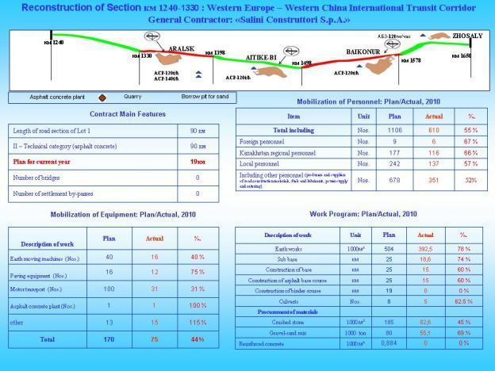

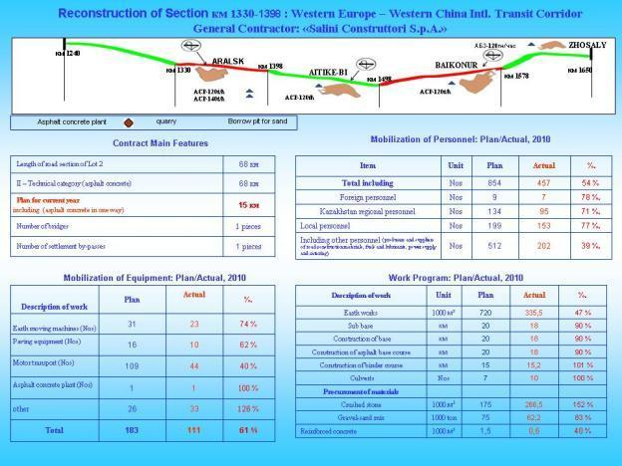

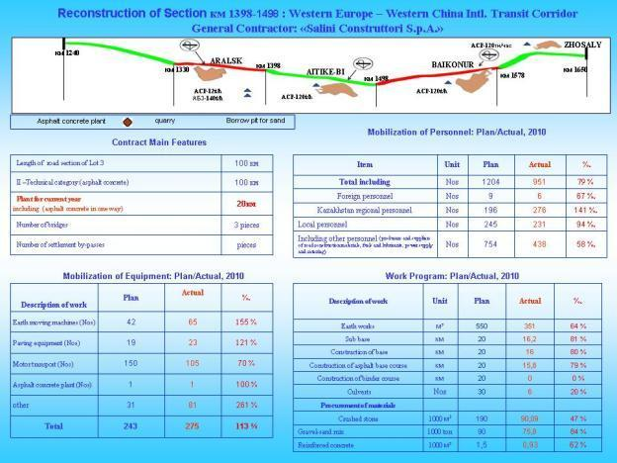

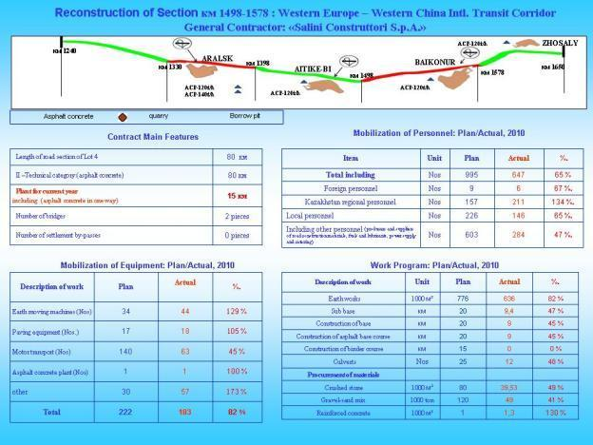

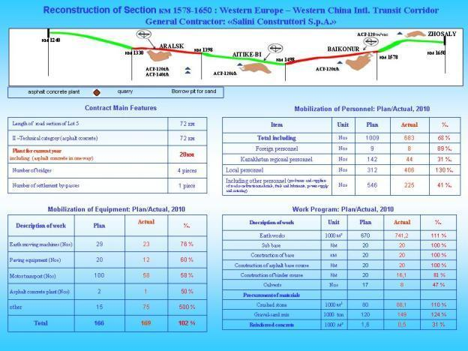

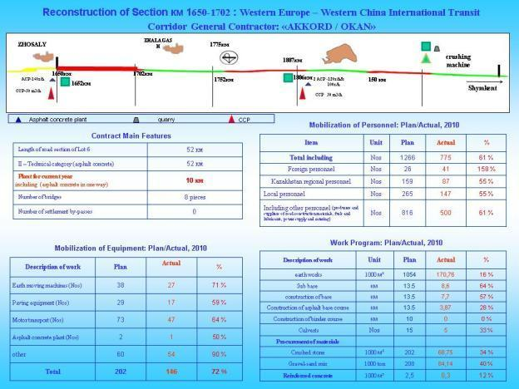

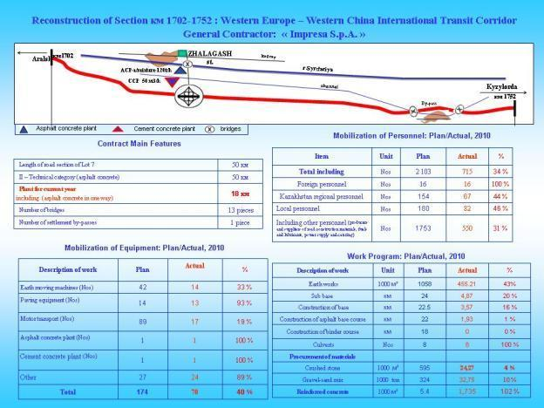

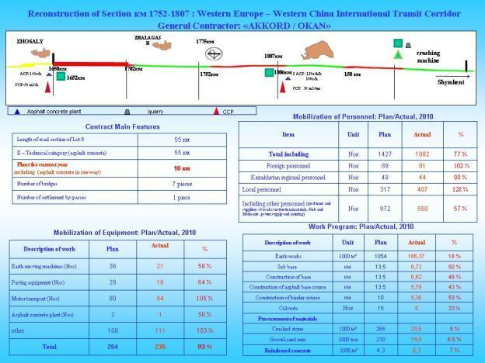

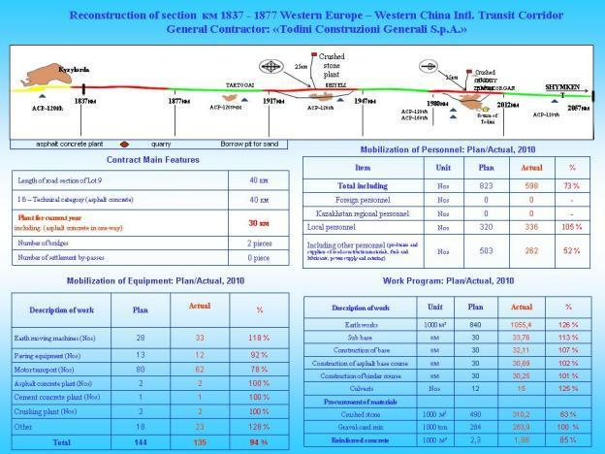

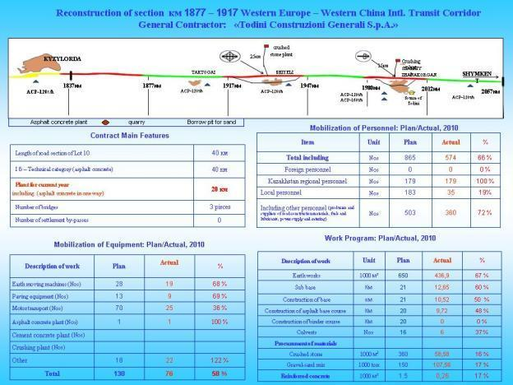

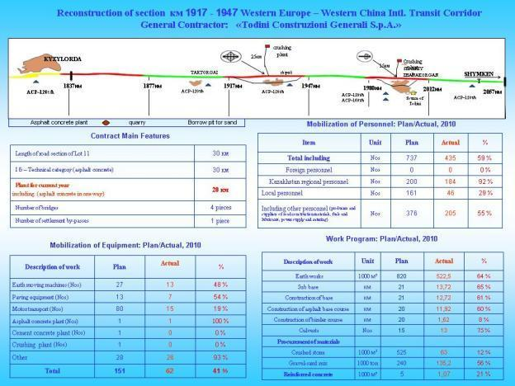

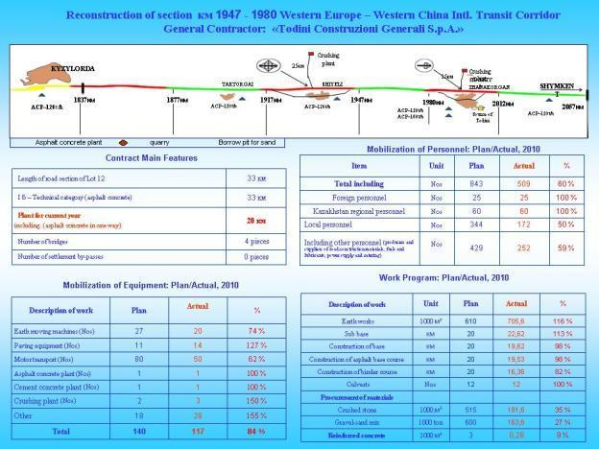

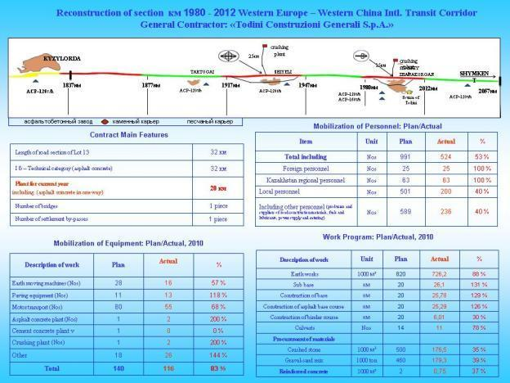

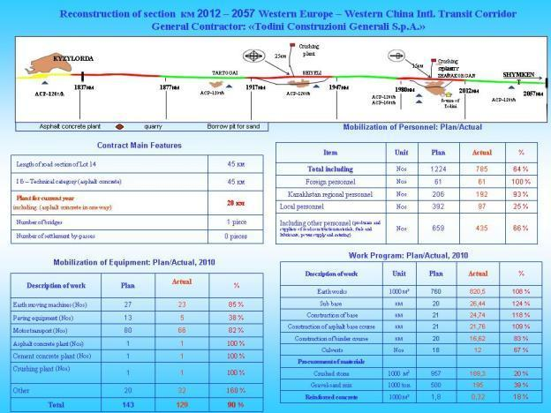

Project Assessment Tool and Status for each Contract (Civil Works and Supervision)
Lot 1 (1240 km – 1330 km) – Contractor: Salini
On average contractor Salini has achieved about 50% of the revised target, which is far away from the satisfactory level. Only 3 IPCs have been raised so far, and only 8% physical progress was achieved against a target of about 20%. This is partly due to the fact that (i) Salini is subcontracting up to 70% of the works to a subcontractor, and (ii) the subcontractor DMSU 22 AB is working on both lots 1 and 2, and does not have the capacity to handle two (large) lots, representing about 160 km together. In addition, the quality of the works being executed needs a lot of improvements especially regarding mixing of water in earthworks, sub base, base course and compaction efforts. Practices and methodology observed on site are considered as inacceptable by the Bank. Isan, the Supervision consultant, does not check properly quality on site. Salini has not yet deployed all the efforts necessary to have all the equipment needed to follow the work plan. There is only one mobile laboratory for lot 1 (representing 90 km of 2 lanes), and it is only 50% equipped. Salini, as main contractor, needs to bring more resources (technical staff, equipment, strategy for work plan, material), to cover up the back log and improve quality. The Bank is expecting Salini to improve the situation significantly by the end of CY 2010.
Lot 2 (1330 km – 1398 km) – Contractor: Salini
On average contractor Salini has achieved about 60% of the revised target which is not satisfactory. Only 3 IPCS have been raised so far, and only 9% physical progress against a target of 15% has been achieved. All the comments and rationale highlighted for lot 1 apply to lot 2. Quality is even worse than on lot 1: during the visit, the Bank could not find any crushed base plant for proper mixing of water and aggregate. First layer of asphalt was being laid on crushed stone base at some sections without proper coverage of prime coat. The Bank witnessed such operation, for which the crushed stone base was not clean and not ready to receive prime tack coat. Prime tack coat was laid heterogeneously, and with no curing time before laying down the first layer of asphalt. All operations observed on site clearly show that (i) no norms for quality control are being followed on site, and (ii) supervision by Isan be very weak, if not inexistent. The Bank is expecting Salini and Isan to improve the situation by the end of current year 2010. The Committee for Roads should also probably consider the replacement of Isan key staff.
Lot 3 (1398 km – 1498 km) – Contractor: Salini
The works under this lot is divided among 5 subcontractors, namely Kazdorinvest, ShimShakh, Vitadorstroy, Standard Oil and Even Roads, the latter being the weakest in terms of working capacity and pace. This does not help with rate of progress, it even makes performance lower, as the main contractor, Salini, has to manage and coordinate with many subcontractors. Progress is very low, with no asphalt activity started as of now. On average Salini has achieved about 30% of the revised target progress as per work plan. Only 3 IPCs have been raised until now, representing 8% physical progress. In addition, quality of earthwork and granular layer are not satisfactory. No proper mixing of material with water was observed. There is only one Hot Mix Plant in Kazalinsk to provide asphalt for both lots 3 and 4, which (i) not compliant with contract, and; (ii) not sufficient to follow work plan. The Bank finds such situation inacceptable. Salini needs to revise his work plan and bring more resources. Quality needs to be improved, with a reinforced checking on site by the Supervision consultant, Isan.
Lot 4 (1498 km – 1578 km) – Contractor: Salini
There are at present two subcontractors, namely Kazdorstroy and Zhylvoi Story Servis, who are working on 40 km each. On average, the main contractor, Salini, can only present a progress of 35% compared to target as per work plan. Only two IPCs have been raised as of today, which represent only 7% of physical progress, against a target of 15%. Quality is also very low on this very lot, earthworks and granular material layer both need improvements. It is reported that old granular sub base material taken from the previously existing road is being mixed with new sub base material without control. The Bank finds such situation inacceptable. Salini needs to revise his work plan and bring more resources. Quality needs to be improved, with a reinforced checking on site by the Supervision consultant, Isan.
Lot 5 (1578 km – 1650 km) – Contractor: Salini
At present the subcontractor, Dorstroy, has achieved 47% of the revised target progress for contractor Salini. Progress is satisfactory as the quality has been taken care of seriously. Dostroy is reported to work seriously, and has already started erecting a second Hot Mix Plant to cope with the increased pace of works in 2011, despite having already one plan in operations for this lot 5. Sufficient quantity of material was found lying in stockpiles. The laboratory has been transferred to the Hot Mix Plant site in order to provide with more working space, and has been found acceptable. The Supervision consultant Kazdorproect is doing proper checking on site and of quantities.

Lot 6 (1650 km – 1702 km) – Contractor: JV Akkord / Okan
The main contractor JV Akkord / Okan has subcontracted 20% of the works to the subcontractors Kiran and Akzhol. Both subcontractors have achieved only 20% of the target as per work plan, which is not acceptable. So far only 600 meters of sub base have been laid. Rate of progress is suffering from lack of equipment, lack of skilled staff, and manpower. The multiple recent changes in the management of Akkord have also had a substantial negative impact of the performance. It is also worth noticing that the partner Okan is not providing any input in the project under the JV. This contract is about 5 months behind schedule, and no IPC has been raised so far. One positive point is the quality of the laboratory which, even if it is not certified yet, is well equipped, spacious and fully functional. The main contractor should also revise its strategy to bring in more subcontractors, as the Bank analysis has led to the conclusions that such approach does not impact positively performance, and would even decrease it, while requiring more managerial and coordination efforts. The Supervision consultant Kazdorproect is doing a very professional work, however should consider avoiding overly detailed analysis and checking that are slowing down the progress. The Bank is expecting the Supervision consultant to provide practical solutions and ideas to the contractor in order to move forwards with progress.
Lot 7 (1702 km – 1752 km) – Contractor: Impresa
Main contractor Impresa is subcontracting up to 60% of the works to local subcontractors Biz-Kz, Kun-Kb, and Mer-Story, while bringing in 3 other subcontractors for specialized works. So far only 1.3 km of sub base and 1.0 km of crushed base have been laid out. This results in the fact that only 20% of the targeted progress has been achieved. Only one IPC has been raised so far. Impresa is about 4 to 5 months behind schedule, and the strategy that consists in bringing in more subcontractors is not likely going to help with performance, especially because it was observed that Impresa is not performing in the communication and coordination with its subcontractors. In addition, bad planning, bad organization of the contractor and delay in commencement because of errors in the original design (not due to Impresa) add to the low progress and overall delay. Impresa has established a small laboratory in Akjarma, however it needs to be transferred to the Hot Mix Plant site, and would require more equipment before certification. There are no plans for installation of crushed base plant.
Lot 8 (1752 km – 1807 km) – Contractor: JV Akkord / Okan
The main contractor JV Akkord / Okan has subcontracted 20% of the works to the subcontractor Shymkent Kurilis Montaj and have completed only 25% of their target progress as per work plan. They are nearly 4 months behind schedule. So far they have been able to raise one IPC only. Equipment is either missing, or in under repair (ex: 80% of the trucks are not functioning and are been repaired), if not waiting to receive spare parts. The positive aspect under this lot is the quality of the site, i.e. the medical facilities and services, the canteen, the laboratory, and the office, which bring a comfortable working environment. In addition, Hot Mix Plan and Crush Base Plant have been erected and are operational. The main contractor should also revise its strategy to bring in more subcontractors, as the Bank analysis has led to the conclusions that such approach does not impact positively performance, and would even decrease it, while requiring more managerial and coordination efforts. The Supervision consultant Kazdorproect is doing a very professional work, however should consider avoiding overly detailed analysis and checking that are slowing down the progress. The Bank is expecting the Supervision consultant to provide practical solutions and ideas to the contractor in order to move forwards with progress.
Lot 9 (1837 km – 1877 km) – Contractor: Todini
The main contractor, Todini, is subcontracting 75% of the works to the well experienced and locally implanted subcontractor UAD. Progress is 100% compliant with target as per work plan. Contractor, through UAD, has enough material stock piled at plant site. A laboratory has been established in Kyzylorda and is operational. The quality of the works executed is good, even if evenness (quality of riding) of the 2nd layer of asphalt could have been expected to be better. Safety aspects along this contract need to be improved, including enforcement of rules and measures on site. The Supervision consultant Roughton and DBUK are performing well, both in terms of presence on site, enforcement, and working towards performance.
Lot 10 (1877 km – 1917 km) – Contractor: Todini
The main contractor, Todini, has subcontracted about 75% of the works to the subcontractor Kazsevautodor, who has achieved only 40% of the target as per work plan. This is mainly due to the fact that the same subcontractor, Kazsevautodor, is also doing 75% of the works for lot 11, and does not have the capacity to handle these two lots in parallel. Contractor Todini needs to bring in more resources (mainly equipment and manpower) to cope up with progress. The Hot Mix Plant is now fully operational and of good quality. One of the noncompliance and negative point observed during the review is the fact that the contractor Todini has made only one combined laboratory for lot 10 and 11 in Shelly. The Supervision consultant Roughton and DBUK are performing well, both in terms of presence on site, enforcement, and working towards performance.
Lot 11 (1917 km – 1948 km) – Contractor: Todini
The main contractor, Todini, has subcontracted about 75% of the works to the subcontractor Kazsevautodor, who has achieved only 40% of the target as per work plan. As explained for lot 10, this is mainly due to the fact that the same subcontractor, Kazsevautodor, is doing 75% of the works for both lots 10 and 11, and does not have the capacity to handle these two lots in parallel. Contractor Todini needs to bring in more resources (mainly equipment and manpower) to cope up with progress. The Hot Mix Plant is now fully operational and of good quality. Again, one of the noncompliance and negative point observed during the review is the fact that the contractor Todini has made only one combined laboratory for lot 10 and 11 in Shelly. In addition, the Contractor does not have any crushed base mixing plant. This is likely to jeopardize quality of the works, while it has been reported that mixing of water in embankment and sub base compaction efforts would need to be improved. The Supervision consultant Roughton and DBUK are performing well, both in terms of presence on site, enforcement, and working towards performance.
Lot 12 (1948 km – 1980 km) – Contractor: Todini
The main contractor, Todini, is doing most of the works under this lot (about 80%), and has achieved about 60% of the targeted progress as per work plan, which includes the completion of 13 km of sub base, about 12km of crushed base course, 12 km of 1st layer of asphalt, and 7 km of 2nd layer of asphalt. It is considered that the contractor will achieve about 85% of the target by the end of the year. Quality of the works and the laboratory were found satisfactory. Safety aspects are acceptable. Both office and work camp are found of excellent quality, and providing workforce with a good working environment.
Lot 13 (1980 km – 2012 km) – Contractor: Todini
The main contractor, Todini, is doing most of the works under this lot (about 80%), and has achieved about 60% of the targeted progress as per work plan, which includes the completion of 13 km of sub base, about 12km of crushed base course, 10 km of 1st layer of asphalt, and 6 km of 2nd layer of asphalt. It is considered that the contractor will achieve about 85% of the target by the end of the year. Quality of the works and the laboratory were found satisfactory. Safety aspects are acceptable. Both office and work camp are found of excellent quality, and providing workforce with a good working environment.
Lot 14 (2012 km – 2057 km) – Contractor: Todini
The main contractor, Todini, is subcontracting 75% of the works to the subcontractor Sine Merdostroy who has achieved about 75% of targeted progress until now and is expected to be able to achieve about 95% of the target by the end of 2010. They have executed 18 km of granular sub base and 13 km of crushed base course, and about 10 km of 1st layer of asphalt. Quality of the works and the laboratory were found satisfactory. Safety aspects are acceptable. Both office and work camp are found of excellent quality, and providing workforce with a good working environment.

Radar Charts - Results as of September 2010
Lot 1 (1240 km – 1330 km) – Contractor: Salini
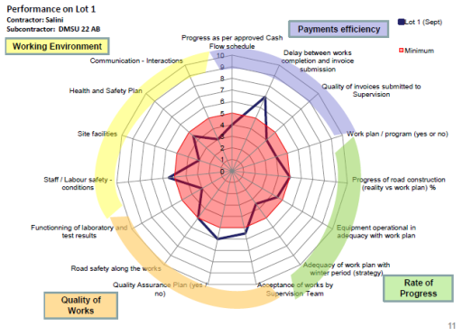
Lot 2 (1330 km – 1398 km) – Contractor: Salini
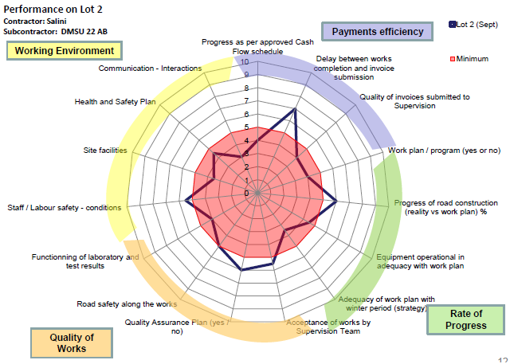
Lot 3 (1398 km – 1498 km) – Contractor: Salini
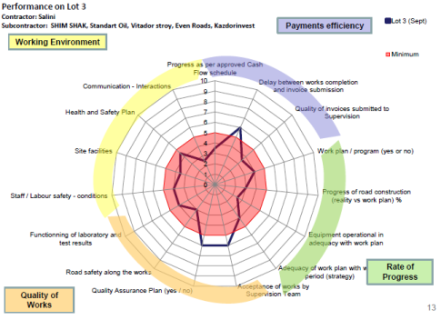

Lot 4 (1498 km – 1578 km) – Contractor: Salini
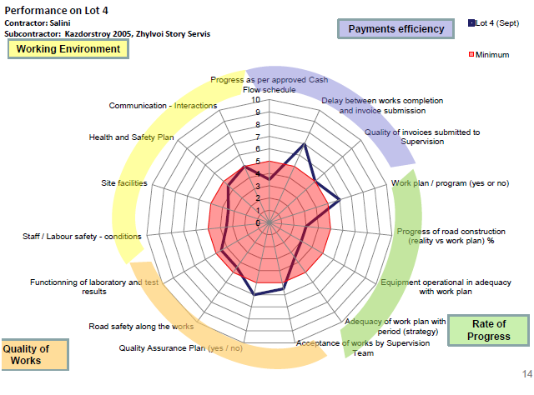

Lot 5 (1578 km – 1650 km) – Contractor: Salini
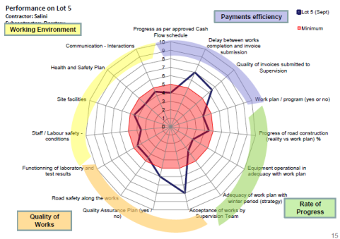
Lot 6 (1650 km – 1702 km) – Contractor: JV Akkord / Okan
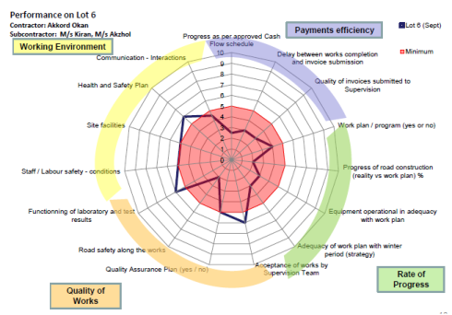

Lot 7 (1702 km – 1752 km) – Contractor: Impresa
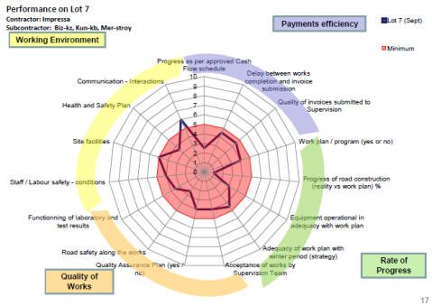
Lot 8 (1752 km – 1807 km) – Contractor: JV Akkord / Okan
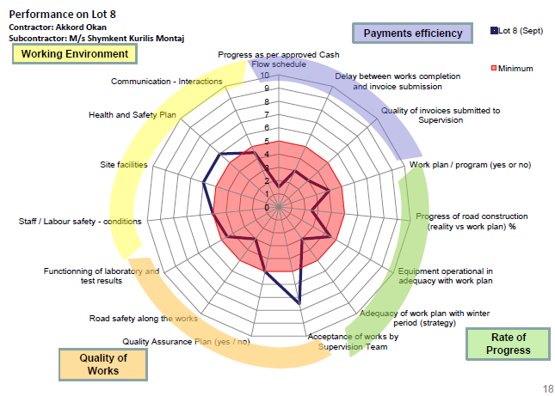

Lot 9 (1837 km – 1877 km) – Contractor: Todini
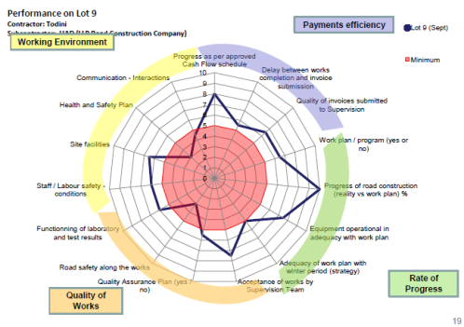
Lot 10 (1877 km – 1917 km) – Contractor: Todini
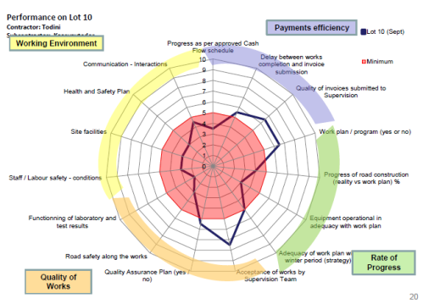

Lot 11 (1917 km – 1948 km) – Contractor: Todini
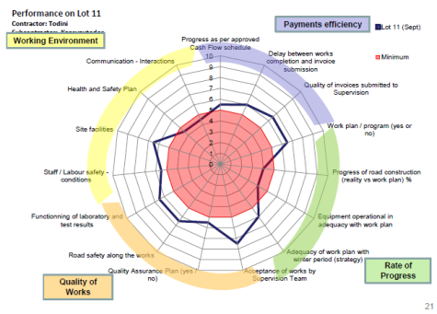
Lot 12 (1948 km – 1980 km) – Contractor: Todini
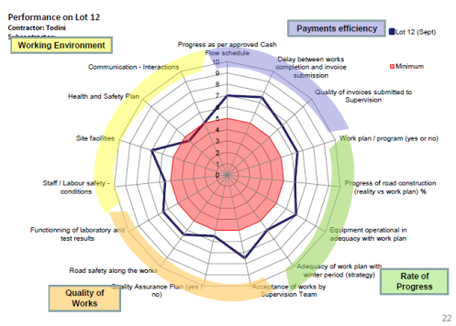

Lot 13 (1980 km – 2012 km) – Contractor: Todini
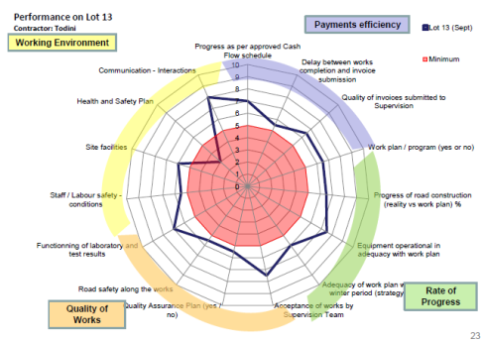

Lot 14 (2012 km – 2057 km) – Contractor: Todini
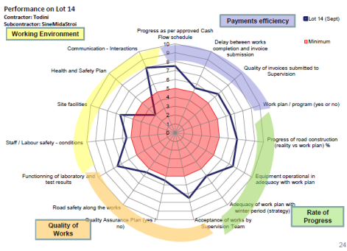

Supervision Consultant ISAN
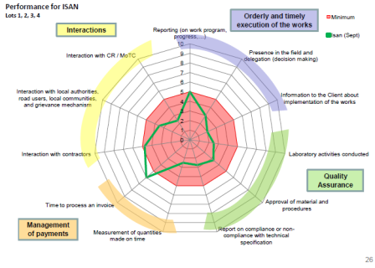

Supervision Consultant KazdorProect
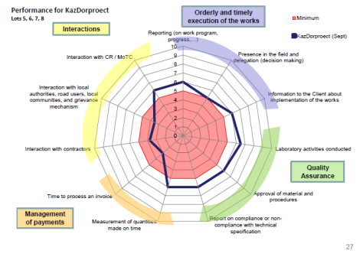

Supervision Consultant DongSung
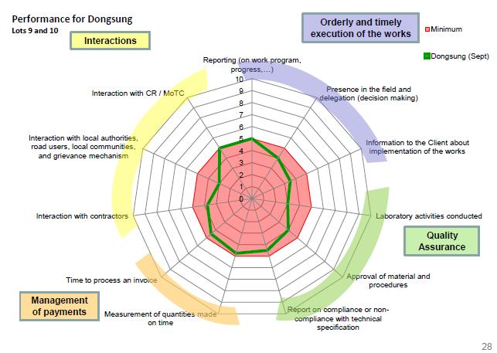

Supervision Consultant Roughton
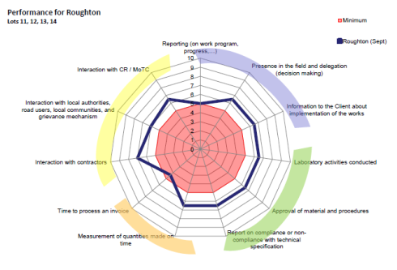

List of Supervision Consultant Staff Replacements

Information of all the replaced staff’s of Supervision Consultancy in Kyzylorda Region
№ | Name of Consultancy |  | Position | Previous | Substitution | Date of submission to the CoR | Remarks
1 | Dongsung Engineering in association with Zhol Sapa LLP |  | Project Manager | Mr. Yoon Hee Kun | Mr. Baek Yoong In | 02.11.2010 | approved
1 |  |  | Deputy project manager | Mr. Jin Sung Hak | Mr. Lee Sang Chul | 02.04.2010 | approved
1 |  |  | Deputy project manager | Mr. Lee Sang Chul | Mr. Cho Han Kyung | 21.07.2010 | approved
1 |  |  | Supervision Engineer | Mr. An Chang Deog | Mr. Hwang Bongkyu | 02.04.2010 | approved
1 |  |  | Supervision Engineer | Mr. Pak Yui Sok | Mr. Koo Ja Won | 21.07.2010 | approved
1 |  |  | Supervision Engineer | Mr. Hwang Bongkyu | Mr. Dhana Raj Sapkota | 26.01.2011 | approved
1 |  |  | Road Engineer | Ms. Tatayana Medvedeva | Mr. Aleksandr Cherkov | 13.03.2010 | approved
1 |  |  | Road Engineer | Mr. Erbol Aitbayev | Mr. Yerzhan Tleuliyev | 13.03.2010 | approved
1 |  |  | Road Engineer | Mr. Talgat Kardiev | Mr. Erkebulan Zhumanov | 02.04.2010 | approved
1 |  |  | Soil and Material Engineer | Mr. Kuanysh Kaliyev | Mr. Zhanabai Basharov | 13.03.2010 | approved
1 |  |  | Soil and Material Engineer | Ms. Kulzhazira Kairbekova | Mr. Nurlan Saduakasov | 13.03.2010 | approved
1 |  |  | Quantity Engineer | Mr. Ruslan Bektemirov | Ms. Almagul Ovechkina | 13.03.2010 | approved
1 |  |  | Quantity Engineer | Mr. Kairat Kudabayev | Mr. Erbol Primbetov | 13.03.2010 | approved
1 |  |  | Quantity Engineer | Mr. Anuar Zhaksymbtov | Mr. Rinat Autalipov | 13.03.2010 | approved
1 |  |  | Quantity Engineer | Mr. Rinat Autalipov | Mr. Askar Aubakirov | 02.11.2010 | approved
1 |  |  | Bridge Engineer | Mr. Andrey Ancheev | Mr. Zhanbolat Abishev | 13.03.2010 | approved
1 |  |  | Bridge Engineer | Ms. Tatayana Fishukova | Mr. Bolat Bereshev | 13.03.2010 | not approved
1 |  |  | Bridge Engineer | Ms. Tatayana Fishukova | Ms. Tamara Peridrienko | 02.04.2010 | approved
1 |  |  | Land Surveyor | Mr. Yerlan Nietbayev | Mr. Syrym Tanabayev | 02.04.2010 | approved
1 |  |  | Laboratory Assistant | Mr. Aldan Merzhoev | Mr. Saulet Eleusizov | 02.04.2010 | approved
1 |  |  | Laboratory Assistant | Ms. Anna Surzhikova | Ms. Aiguk Amandykova | 02.04.2010 | approved
1 |  |  | Laboratory Assistant | Ms. Umitai Valitova | Ms. Arai Surgalina | 02.04.2010 | approved
1 |  |  | Laboratory Assistant | Ms. Arai Surgalina | Ms. Lyubov Ryzhkova | 18.08.2010 | approved
1 |  |  | Translator | Ms. Helen Popandopulo | Ms. Inna Lebedeva | 02.04.2010 | approved
1 |  |  | Translator | Ms. Meruert Omarova | Ms. Indira Dzhelderbaeva | 02.04.2010 | approved
1 |  |  | Translator | Ms. Elmira Satymbekova | Ms. Natalya Pak | 02.04.2010 | approved
1 |  |  | Translator | Mr. Askar Tagashbaev | Ms. Zhuldyzai Seitimova | 02.04.2010 | approved
1 |  |  | Translator | Ms. Inna Lebedeva | Mr. Gabit Auelbek | 18.08.2010 | approved
1 |  |  | Translator | Ms. Zhuldyzai Seitimova | Ms. Inna Lebedeva | 16.09.2010 | approved
2 | ISAN Corporation in association with Zhol Sapa LLP |  | Deputy project manager | Mr. Lee Il-Cyu | Mr. Lee Jong-Yoon | 13.03.2010 | approved
2 |  |  | Deputy project manager | Mr. Lee Jong-Yoon | Mr. Kim Choong Kook | 16.03.2010 | approved
2 |  |  | Supervision Engineer | Mr. Cho Byung Nam | Mr. Kim Han-Kyung | 13.03.2010 | approved
2 |  |  | Supervision Engineer | Mr. Kim Ji Ha | Mr. Hwang Jae Bum | 16.03.2010 | approved
2 |  |  | Supervision Engineer | Mr. Kim Han-Kyung | Mr. Lee Jong-Yoon | 16.03.2010 | not approved
2 |  |  | Road Engineer | Mr. Kunanbai Shaharbayev | Mr. Anatoly Saprygin | 13.03.2010 | approved
2 |  |  | Road Engineer | Ms. Nina Machina | Ms. Nina Kuhta | 13.03.2010 | approved
2 |  |  | Road Engineer | Mr. Grigoriy Danilov | Mr. Alexandr Fidchenko | 20.08.2010 | approved
2 |  |  | Soil and Material Engineer | Ms. Valentina Larina | Mr. Bazarbai Gulmanov | 13.03.2010 | approved
2 |  |  | Soil and Material Engineer | Mr. Erik Amirbayev | Mr. Ayan Karimov | 13.03.2010 | approved
2 |  |  | Quantity Engineer | Mr. Muratbek Almuhanov | Mr. Alibek Baibolatov | 13.03.2010 | approved
2 |  |  | Quantity Engineer | Ms. Nataliya Bolottseva | Mr. Dastan Daurenbayev | 13.03.2010 | approved
2 |  |  | Quantity Engineer | Mr. Ayan Karimov | Mr. Yerbol Eskendirov | 13.03.2010 | approved
2 |  |  | Quantity Engineer | Mr. Nurzhan Kyrykbayev | Mr. Dauren Musakul | 13.03.2010 | approved
2 |  |  | Bridge Engineer | Mr. Vladimir Donskiy | Mr. Vadim Kiknadze | 13.03.2010 | approved
2 |  |  | Bridge Engineer | Ms. Asiya Ashirbekova | Mr. Almas Absalimova | 13.03.2010 | approved
2 |  |  | Bridge Engineer | Mr. Nikolai Tsitsenko | Mr. Erkin Rayimov | 13.03.2010 | approved
2 |  |  | Translator | Mr. Kaiyrbek Adilkhan | Mr. Almat Maksutov | 18.08.2010 | approved
3 | Roughton International in association with DBUK |  | Road Engineer | Mr. Sadovskiy | Mr. Akhmetjan Bimenov | 02.04.2010 | approved
3 |  |  | Road Engineer | Ms. Safronova | Mr. Abylzhan Alpysbayev | 02.04.2010 | approved
3 |  |  | Road Engineer | Mr. Snytko | Mr. Saydnabi Aliakbarov | 02.04.2010 | approved
3 |  |  | Road Engineer | Mr. Eremin | Mr. Yerkin Yerzhaev | 20.08.2010 | approved
3 |  |  | Soil and Material Engineer | Ms. Sadovskaya | Mr. Ermek Rakhiev | 02.04.2010 | approved
3 |  |  | Soil and Material Engineer | Mr. Kutin | Mr. Mukhitdin Turzhanov | 02.04.2010 | approved
3 |  |  | Soil and Material Engineer | Ms. Shagiakhmetova | Mr. Abdygani Sarbasov | 02.04.2010 | not approved
3 |  |  | Soil and Material Engineer | Ms. Shagiakhmetova | Mr. Alexei Zavarukhin | 20.08.2010 | approved
3 |  |  | Soil and Material Engineer | Mr. Erkinbekov | Ms. Tatyana Kalischeva | 20.08.2010 | approved
3 |  |  | Quantity Engineer | Mr. Zhanserkeev | Mr. Zhusupbai Bekzhigitov | 02.04.2010 | approved
3 |  |  | Quantity Engineer | Mr. Auganbaev | Mr. Baurzhan Dabylov | 02.04.2010 | approved
3 |  |  | Environmental Specialist | Mr. Alpysbayev | Ms. Nurpeisova | 02.04.2010 | approved
3 |  |  | Bridge Engineer | Mr. Suleimenov | Mr. Vladimir Pan | 02.04.2010 | not approved
4 | KazDorProject LLP |  | Project Manager | Mr. Yuri Komov | Mr. Boris Goncharov | 02.04.2010 | approved
4 |  |  | Resident Engineer | Mr. Serik Zhubalov | Mr. Aleksei Ulynov | 02.04.2010 | approved
4 |  |  | Resident Engineer | Mr. Aleksandr Maslyakov | Mr. Saparymbet Nurmukhamed | 02.04.2010 | approved
4 |  |  | Contract Specialist | Mr. Sultanbek Karimov | Ms. Nadezhda Tokhtahunova | 02.04.2010 | approved
4 |  |  | Engineer Superviser | Mr. A.Ulyanov | Mr. V.Kuzmenko | 06.06.2010 | approved
4 |  |  | Road Engineer | Ms. Galina Tarakanova | Mr. Karim Makhmedierov | 02.04.2010 | approved
4 |  |  | Soil and Material Engineer | Mr. Khamit Kenzhekulov | Ms. Lyudmila Podkoryova | 02.04.2010 | approved
4 |  |  | Soil and Material Engineer | Ms. Aida Nurkhamytova | Mr. Dmitriy Nevezhenko | 02.04.2010 | approved
4 |  |  | Soil and Material Engineer | Ms. Shagiakhmetova | Mr. Abdygani Sarbasov | 02.04.2010 | not approved
4 |  |  | Quantity Engineer | Ms. Algiya Vorogushina | Mr. Azamat Kalbayev | 02.04.2010 | approved
4 |  |  | Quantity Engineer | Mr. Akhmetbek Sargaldakov | Mr. Radzha Filchagin | 02.04.2010 | approved
4 |  |  | Quantity Engineer | Mr. Sergei Sidorov | Mr. Akhmetzhan Bimenov | 02.04.2010 | approved
4 |  |  | Quantity Engineer | Mr. Bimenov | Mr. Yerezhepov` | 25.05.2010 | approved
4 |  |  | Environmental Specialist | Ms. Valentina Klimova | Ms. Lina Artiuhina | 10.07.2010 | approved
4 |  |  | Bridge Engineer | Ms. Nina Gonchar | Mr. Musodzhon Kadirov | 02.04.2010 | approved
4 |  |  | Bridge Engineer | Mr. Suleimenov | Mr. Vladimir Pan | 02.04.2010 | not approved
4 |  |  | Land Surveyor | Mr. Gennadiy Vladimirov | Ms. Oksana Kritskaya | 02.04.2010 | approved
4 |  |  | Laboratory Assistant | Mr. Sergei Bezolutskiy | Mr. Maksim Kasheev | 02.04.2010 | approved
4 |  |  | Laboratory Assistant | Mr. Anton Bosov | Mr. Daniyar Myrzakanov | 02.04.2010 | approved
4 |  |  | Translator | Ms. Nataliya Koloshona | Mr. Vadim Kovtun | 02.04.2010 | Approved
4 |  |  | Translator | Ms. Rysbekova | Ms. Akerke Mussabekova | 25.05.2010 | approved
4 |  |  | Translator | Ms. Koloshina | Mr. Bahytzhan Dukenbaev | 25.05.2010 | approved

 | Disbursement detail for year 2010
№ | Name of contractor |  | km | Lot | Contract Amount, million KZT | Plan 2010, including advance | Total amount actually paid, million KZT | Disbursement breakdown, million KZT (31 December 2010)
 |  |  |  |  |  |  |  | Jan. |  | Feb |  | Mar |  | Apr |  |  |  |  | May |  |  |  | June |  | July | Aug |  |  |  |  | Sept |  |  |  | Oct |  |  |  | Nov |  | December
 |  |  |  |  |  |  |  | Advance payment
1 | Salini |  | 90 | 1 | 12,061.1 | 3,347.6 | 2,691.1 | 477.2 |  |  |  |  |  |  |  |  |  |  |  |  |  |  |  |  |  | 270.1 |  |  |  |  |  | 763.0 |  |  |  |  |  | 247.9 |  |  | 932.9
2 | Salini |  | 68 | 2 | 10,737.0 | 2,802.7 | 2,938.4 | 424.8 |  |  |  |  |  |  |  |  |  |  |  | 227.7 |  |  |  |  |  |  |  |  |  |  |  | 850.6 |  |  |  |  |  | 299.9 |  |  | 1,135.3
3 | Salini |  | 100 | 3 | 14,468.0 | 4,027.2 | 2,575.1 | 572.5 |  |  |  |  |  |  |  |  |  |  |  | 300.2 |  |  |  |  |  |  |  |  |  |  |  | 588.2 |  |  |  |  |  | 290.8 |  |  | 823.4
4 | Salini |  | 82 | 4 | 12,645.0 | 3,619.0 | 2,687.0 | 500.3 |  |  |  |  |  |  |  |  |  |  |  | 302.9 |  |  |  |  |  | 255.9 |  |  |  |  |  | 368.7 |  |  |  |  |  | 285.4 |  |  | 973.9
5 | Salini |  | 69 | 5 | 10,563.0 | 3,123.0 | 2,796.6 | 417.9 |  |  |  |  |  |  |  |  |  |  |  |  |  |  |  | 241.7 |  |  |  |  |  |  |  | 1,000.2 |  |  |  |  |  | 309.1 |  |  | 827.6
6 | Akkord & Okan |  | 50 | 6 | 8,429.4 | 1,829.7 | 1,084.2 | 152.9 |  |  | 136.0 |  |  |  |  |  |  |  |  |  |  |  |  |  |  |  |  |  |  |  |  | 172.0 |  |  |  |  |  |  |  |  | 623.3
7 | Impresa |  | 49 | 7 | 13,918.4 | 4,067.8 | 2,560.9 | 379.6 |  |  | 1,133.8 |  |  |  |  |  |  |  |  |  |  |  |  |  |  |  |  |  |  |  |  | 316.5 |  |  |  |  |  |  |  |  | 731.1
8 | Akkord & Okan |  | 57 | 8 | 15,085.0 | 3,567.3 | 2,691.5 | 273.6 |  |  | 243.4 |  |  |  |  |  |  |  |  |  |  |  |  |  |  | 313.7 |  |  |  |  |  |  |  |  |  |  |  | 337.9 |  |  | 1,523.0
9 | Todini |  | 40 | 9 | 10,027.3 | 3,492.5 | 4,243.2 | 363.7 |  |  | 11.8 |  |  |  |  |  |  |  |  | 238.9 |  |  |  | 305.5 |  | 531.2 |  |  |  |  | 501.8 | 1,238.5 |  |  |  |  |  | 346.9 |  |  | 704.8
10 | Todini |  | 40 | 10 | 10,072.1 | 2,821.2 | 1,664.4 | 365.3 |  |  |  |  |  |  |  |  |  |  |  |  |  |  |  |  |  | 254.5 |  |  |  |  | 226.2 | 229.7 |  |  |  |  |  | 227.2 |  |  | 361.4
11 | Todini |  | 28 | 11 | 9,431.8 | 3,211.3 | 2,408.1 | 342.1 |  |  |  |  |  |  |  |  |  |  |  |  |  |  |  |  |  | 208.0 |  |  |  |  | 267.9 | 384.1 |  |  |  |  |  | 190.9 |  |  | 1,015.1
12 | Todini |  | 33 | 12 | 8,334.1 | 3,155.5 | 3,421.9 | 302.3 |  |  |  |  |  |  |  |  |  |  |  | 196.2 |  |  |  |  |  | 357.2 |  |  |  |  | 212.3 | 1,043.5 |  |  |  |  |  |  |  |  | 1,310.4
13 | Todini |  | 32 | 13 | 9,234.1 | 3,423.5 | 3,665.5 | 334.9 |  |  |  |  |  |  |  |  |  |  |  | 208.0 |  |  |  | 197.8 |  | 299.6 |  |  |  |  | 312.0 | 1,007.4 |  |  |  |  |  | 189.1 |  |  | 1,116.7
14 | Todini |  | 44 | 14 | 9,797.4 | 4,105.3 | 5,139.4 | 355.4 |  |  | 100.5 |  |  |  |  |  |  |  |  | 287.5 |  |  |  |  |  | 447.1 |  |  |  |  | 552.8 | 1,428.7 |  |  |  |  |  | 257.4 |  |  | 1,710.0
15 | km 1807 – 1837 |  | 28 | 15 | 8,722.2 | 2,400.0 | 0.0
16 | Roughton & DBUK |  |  |  | 1,458.6 | 445.7 | 236.2 |  |  |  |  |  |  | 82.3 |  |  |  |  |  |  |  |  |  |  |  |  |  |  |  |  | 81.5 | 18.5 |  |  |  |  |  | 26.8 |  |  | 27.1
17 | Dongsung & Zhol-Sapa LLP |  |  |  | 1,028.7 | 312.3 | 149.8 |  |  |  |  |  |  | 70.9 |  |  |  |  |  | 11.4 |  |  |  |  |  | 6.4 |  |  |  |  | 16.0 |  |  |  |  |  |  | 45.0
18 | KazDorProekt |  |  |  | 1,190.8 | 318.9 | 219.0 |  |  |  |  |  |  |  |  |  |  |  |  | 50.5 |  |  |  | 25.1 |  | 26.0 |  |  |  |  | 54.3 |  |  |  |  |  |  | 31.6 |  |  | 31.6
19 | Isan Corporation & Zhol-Sapa |  |  |  | 1,234.1 | 375.2 | 136.0 |  |  |  |  |  |  | 85.0 |  |  |  |  |  |  |  |  |  |  |  |  |  |  |  |  |  |  |  |  |  |  |  | 33.5 |  |  | 17.5
20 | SNC-Lavalin Int. Inc |  |  |  | 1,067.1 | 314.3 | 172.0 |  |  |  |  |  |  |  |  |  |  |  |  |  |  |  |  |  |  | 58.9 |  |  |  |  | 17.9 | 50.2 |  |  |  |  |  | 22.5 |  |  | 22.5
Total |  |  |  |  | 169,505.3 | 50,760.0 | 41,480.3 | 5,262.5 |  |  | 1,625.5 |  | 0.0 |  | 238 | 0.0 |  |  |  | 1,823.3 |  |  |  | 770.1 |  |  | 3,029 | 2,243 |  |  | 9,460 |  |  |  |  |  |  | 3,142 |  | 13,888

? The Central Asia Regional Economic Cooperation (CAREC) Program is an ADB-lead partnership program of eight countries and six multilateral institutions working to promote development through cooperation, leading to accelerated economic growth and poverty reduction
? Parties present at the workshop included: Ministry of Transport and Communications, Akimat representatives, South Kazakhstan oblast RC Department, NGOs, Design Institute, Contractor Companies, Mass media representatives, and World Bank.
? The measures included (i) shifting the road alignment away from the existing residences to provide the maximum possible distance between the houses and the new 4-lane road (at minimum this distance is of 17 meters); (ii) constructing a pedestrian underpass at a point close to the local school, a pedestrian crossing and another underpass for livestock; (iii) reconstructing the existing 2-lane road to become a local access road for the residents of thek settlement and construction of bus stops with shelters; (iv) constructing a 3-meter high wall between the new 4-lane road and the reconstructed 2-lane local access road to provide safety and act as a barrier reducing traffic noise and vehicle emissions; (v) planting trees along the new 4-lane bypass road for aesthetic reasons and installing street lights along the existing 2-lane bypass road and at the underpasses to improve personal safety and security, (vi) provide an additional school-bus for the children to reach the school to and from the settlement; and (iii) build a Greenfield bypass outside the city within a period of three to five years.

